

**PR3 WS 2017/18**

Aufgabenblatt Nr.2

Datum: 14.12.2017

Can Arsoy (1530588)

Nico Gensheimer (1613397)

Fabian Munzinger (1529702)

Inhaltsverzeichnis

**Aufgabe 13**

a) insert3

b) insert (filename)3

c) contains………….…………………………………………………………………………………………………………………………..4

d) size……..……….……………………………………………………………………………………………………………………………..4

e) height ………………………………………………………………………………………………………………………………………..5

f) getMax .………………………………………………………………………………………………………………………………………5

g) getMin ……………………………………………………………………………………………………………………………………….6

h) remove...…………………………………………………………………………………………………………………………………….6

I) isEmpty ……………………………………………………………………………………………………………………………………….7

J) addAll ..……………………………………………………………………………………………………………………………………….7

K) printlevelorder…..……………………………………………………………………………………………………………………….8

1. Insert (tree val)

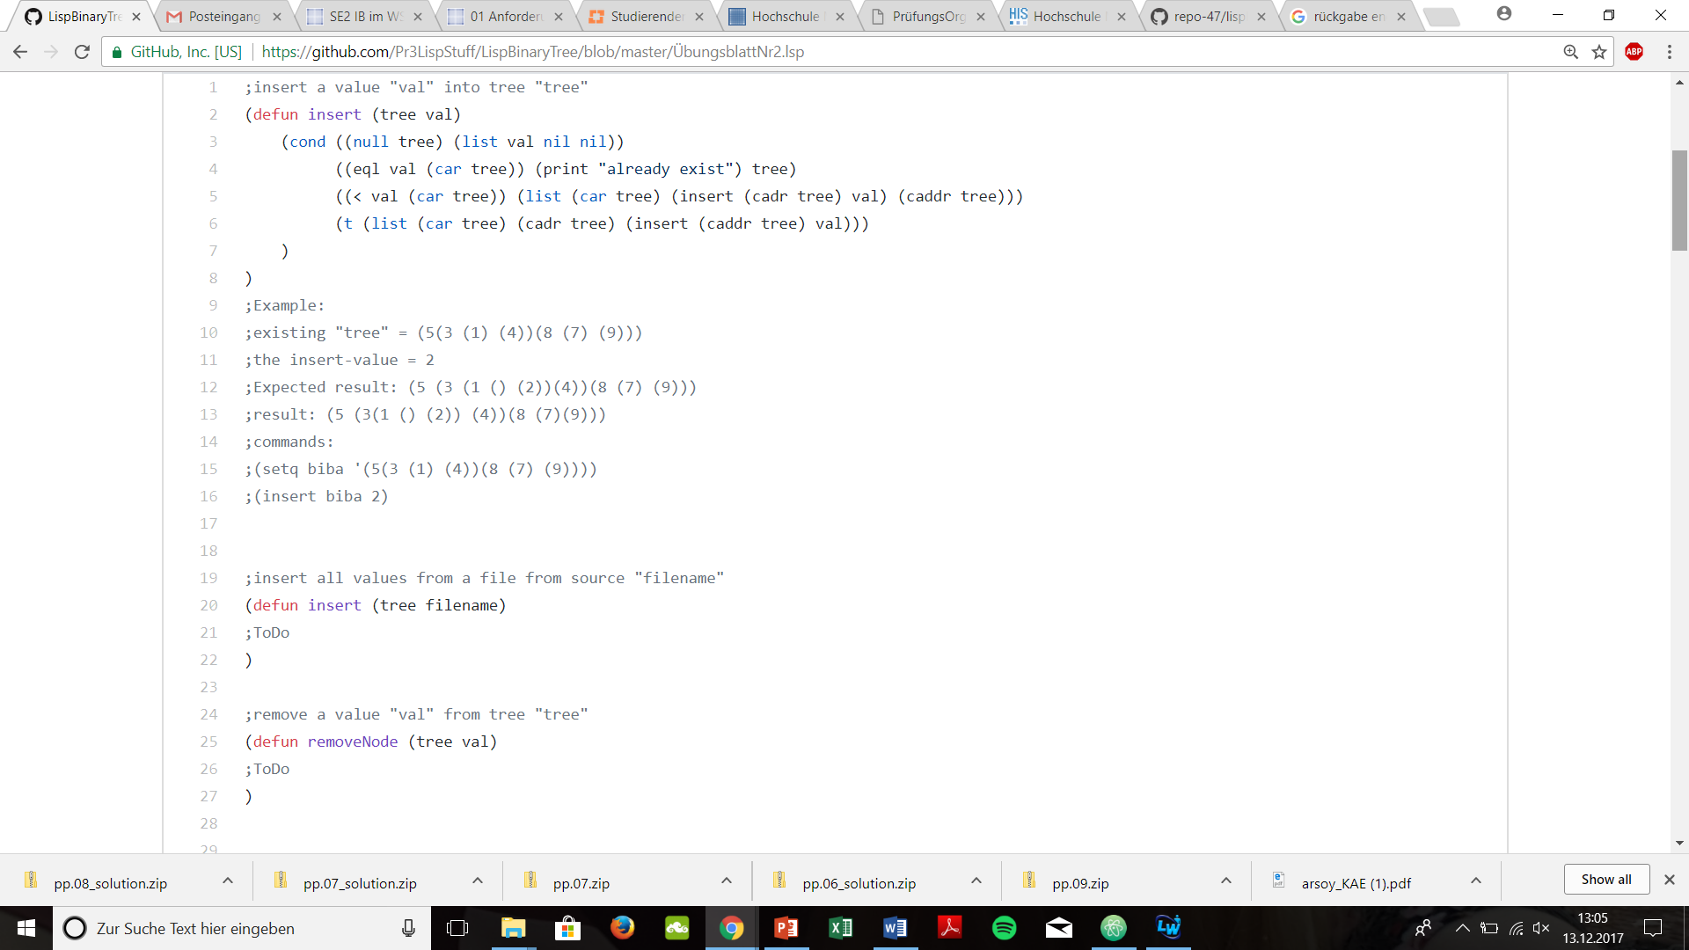

1. Insert (tree filename)

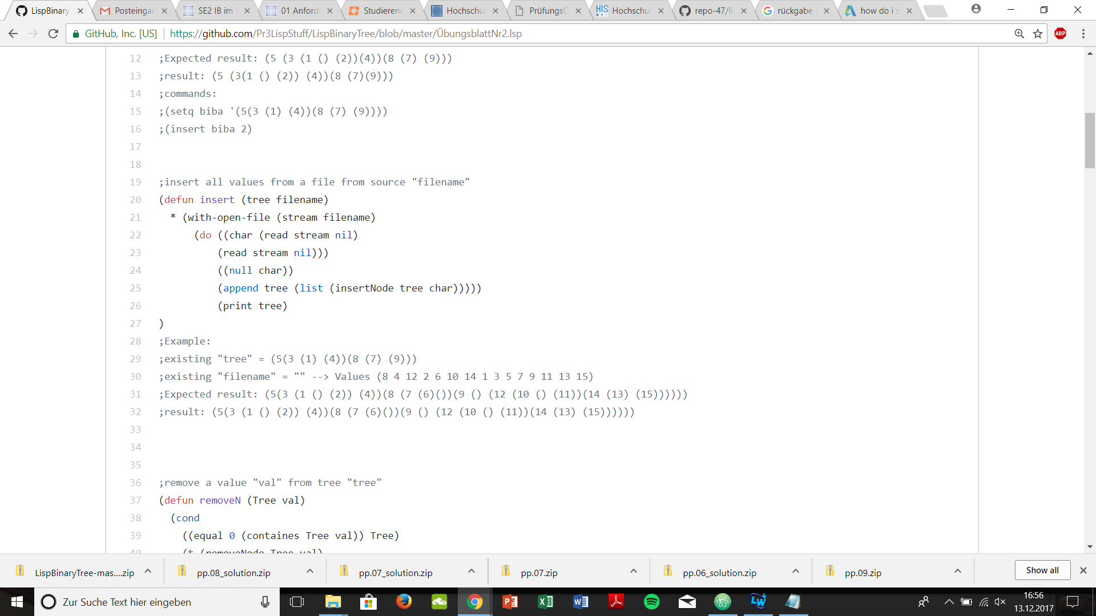

1. Containes (tree val)

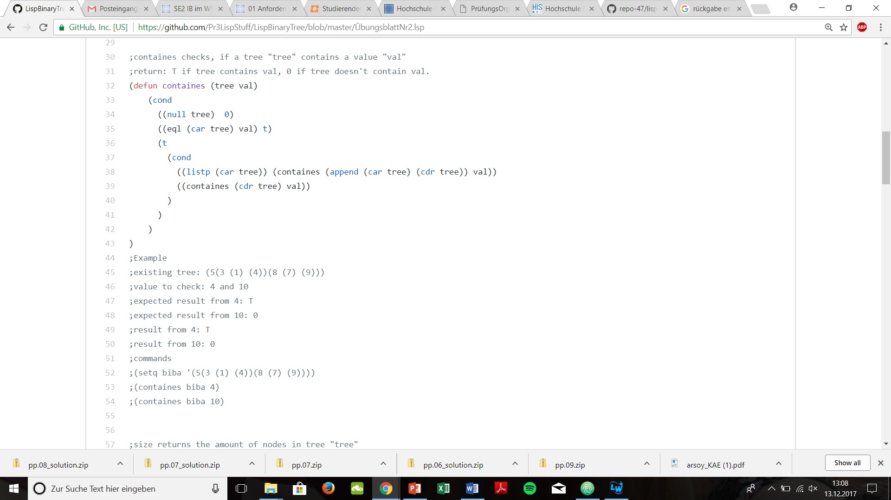

1. Size (tree)

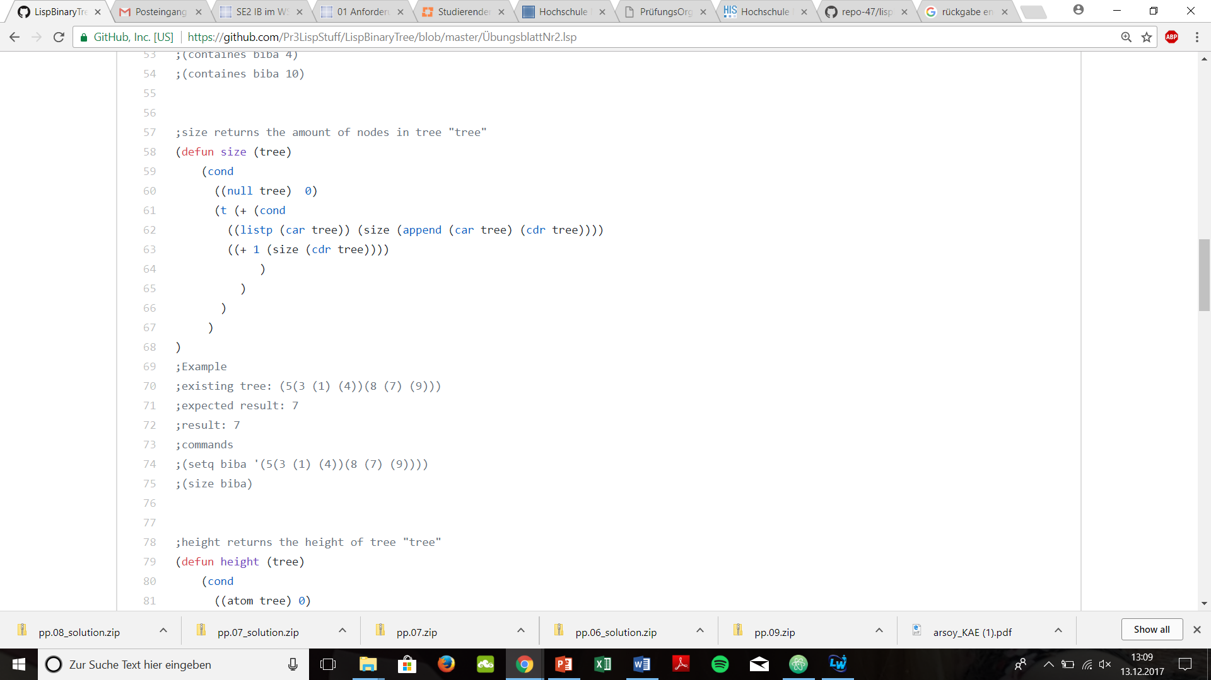

1. Height (tree)

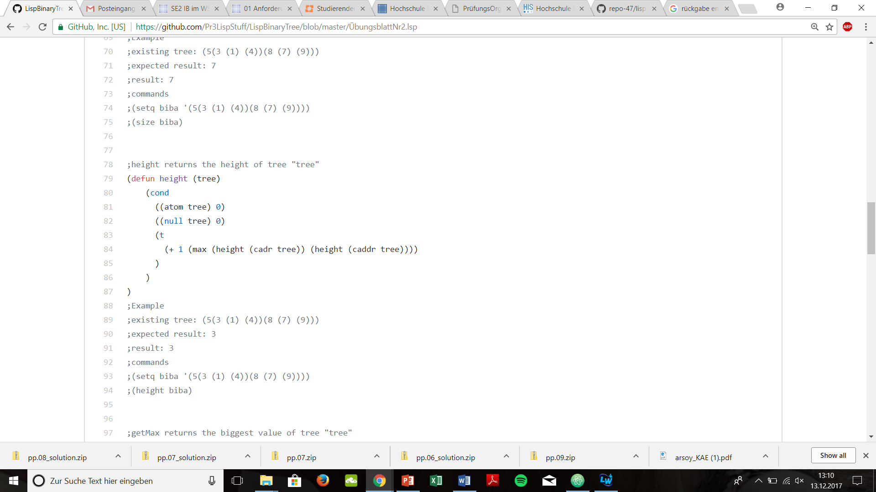

1. getMax (tree)

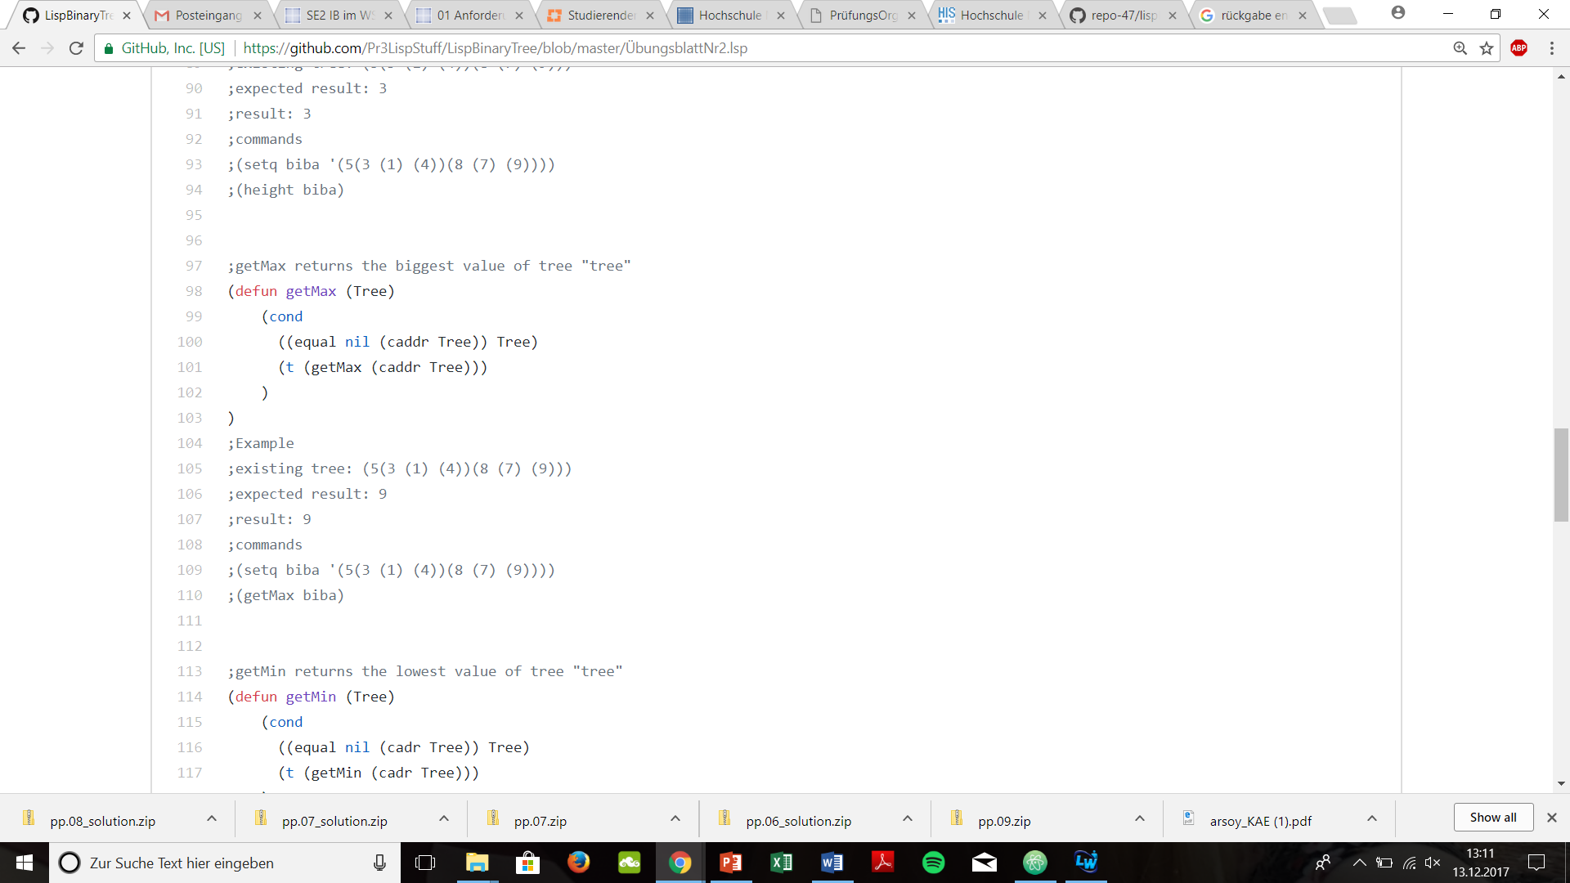

1. getMin (tree)

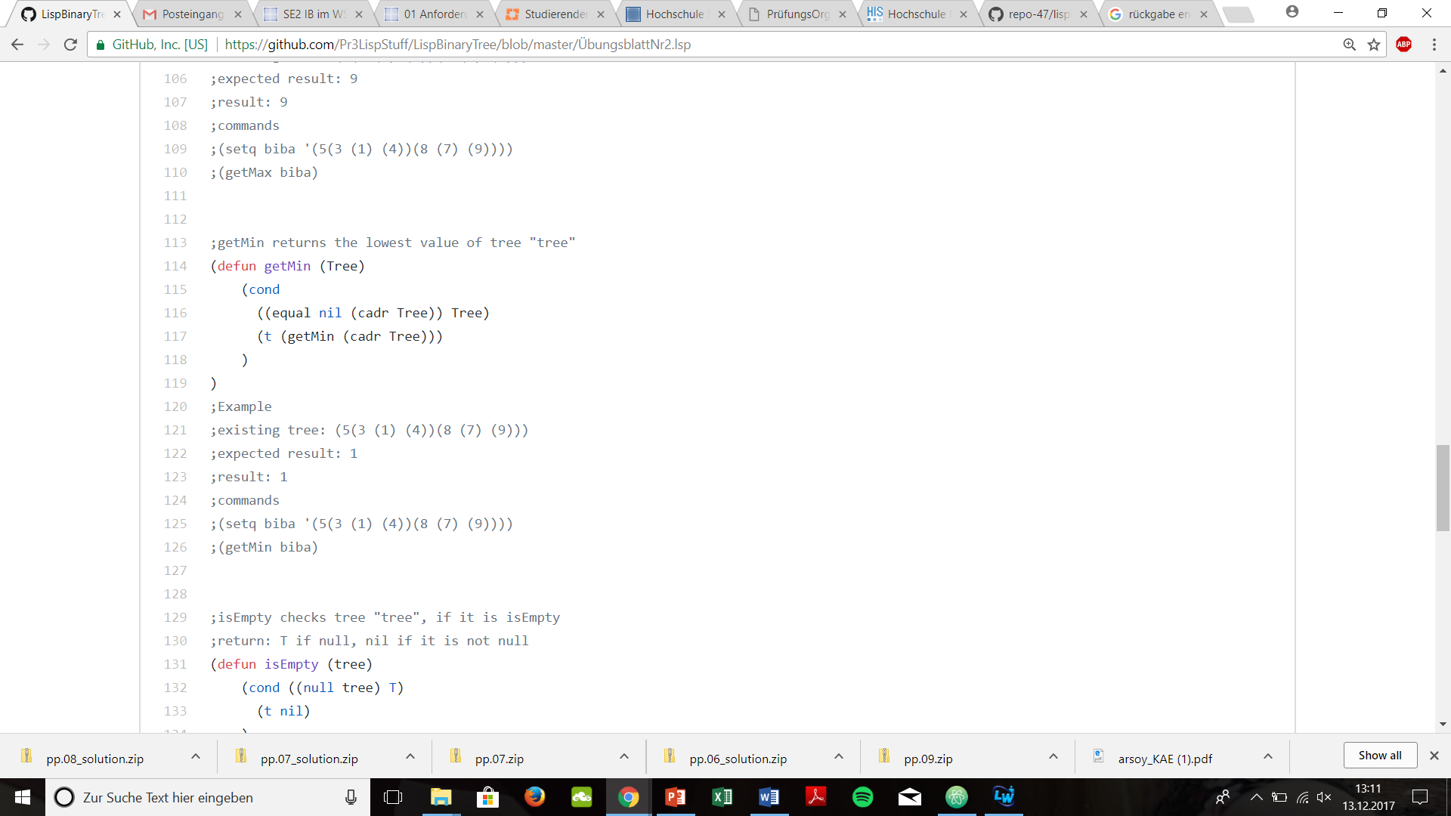

1. remove (tree val)

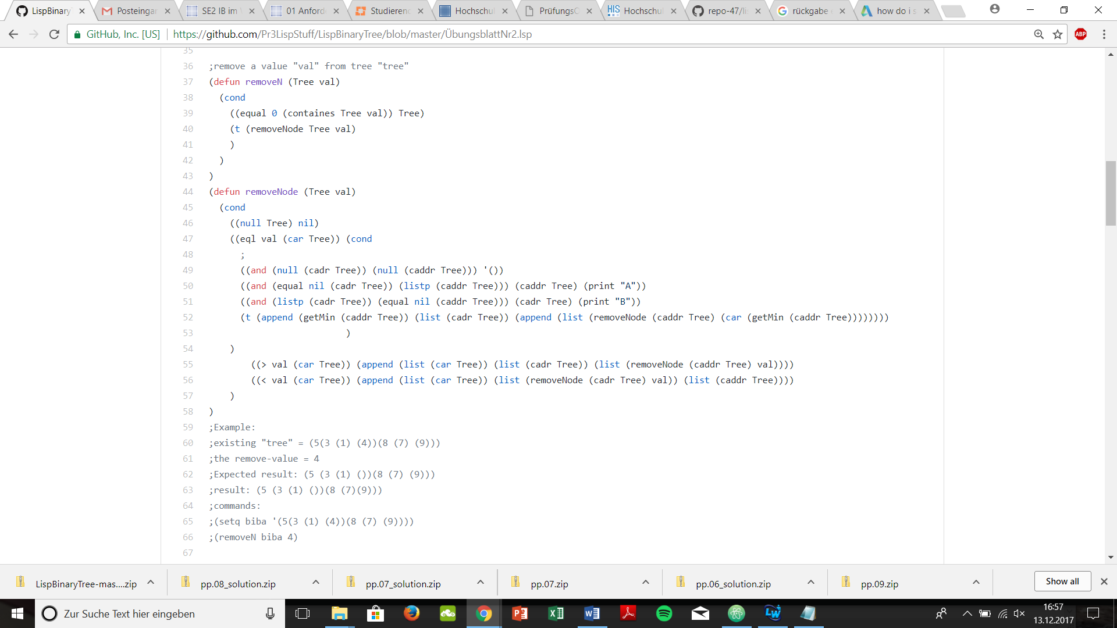

1. isEmpty (tree)

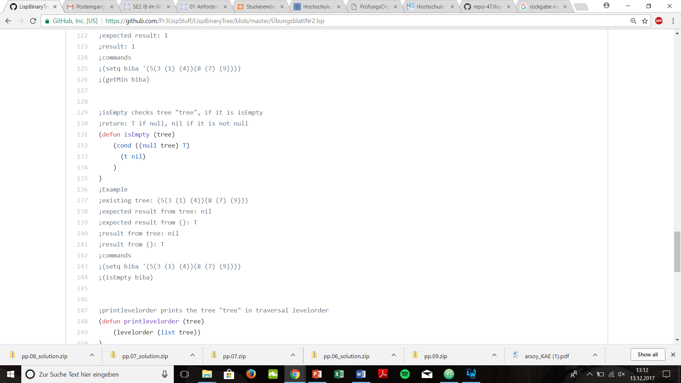

1. addAll (tree otherTree)

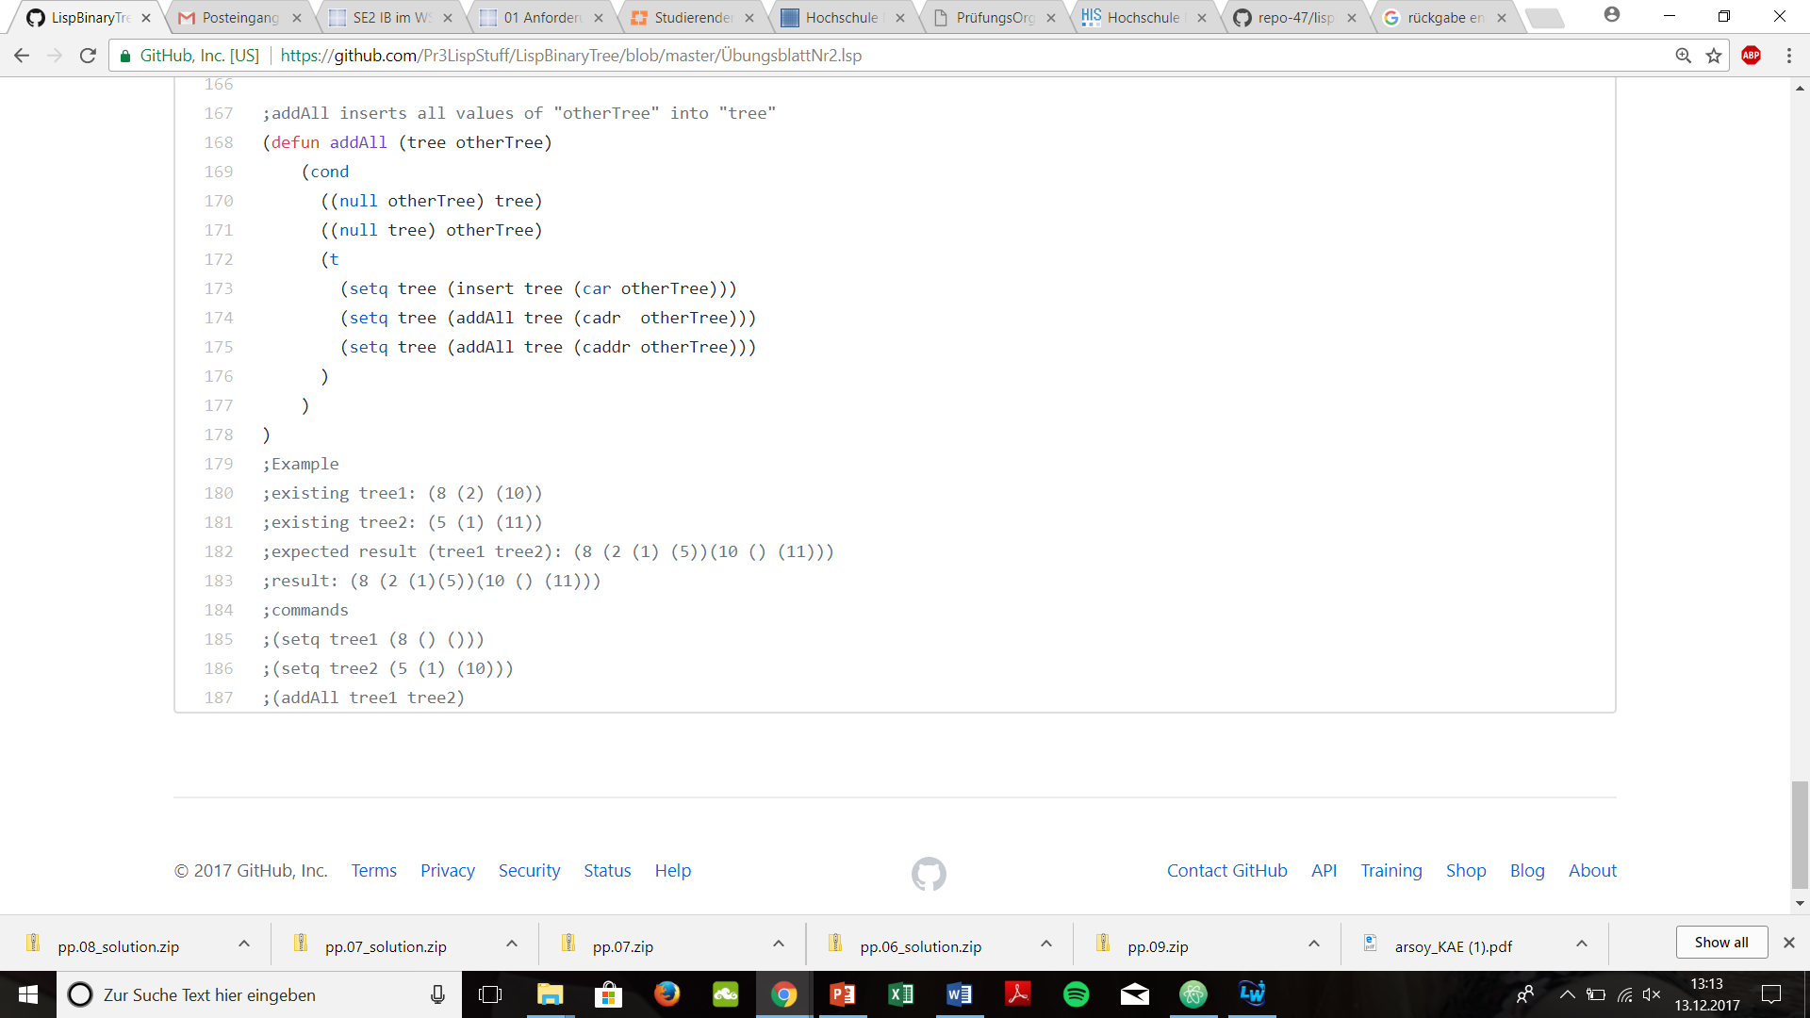

1. printLevelorder (tree)

